1) Shallow copy and class Assignment

Given the following classes:

class Address;
bit [31:0] addr;
function new(bit [31:0] a);
addr = a;
endfunction
endclass

class Packet;
Address addr_obj;
function new();
addr_obj = new(32'hDEADBEEF);
endfunction
endclass
Task:

a) Create two instances of Packet, pkt1 and pkt2.

b) Assign pkt1 to pkt2.

c) Modify the addr in pkt2 to 32'hCAFEBABE.

d) Display the addr of both pkt1 and pkt2 to observe the effect of shallow copy.
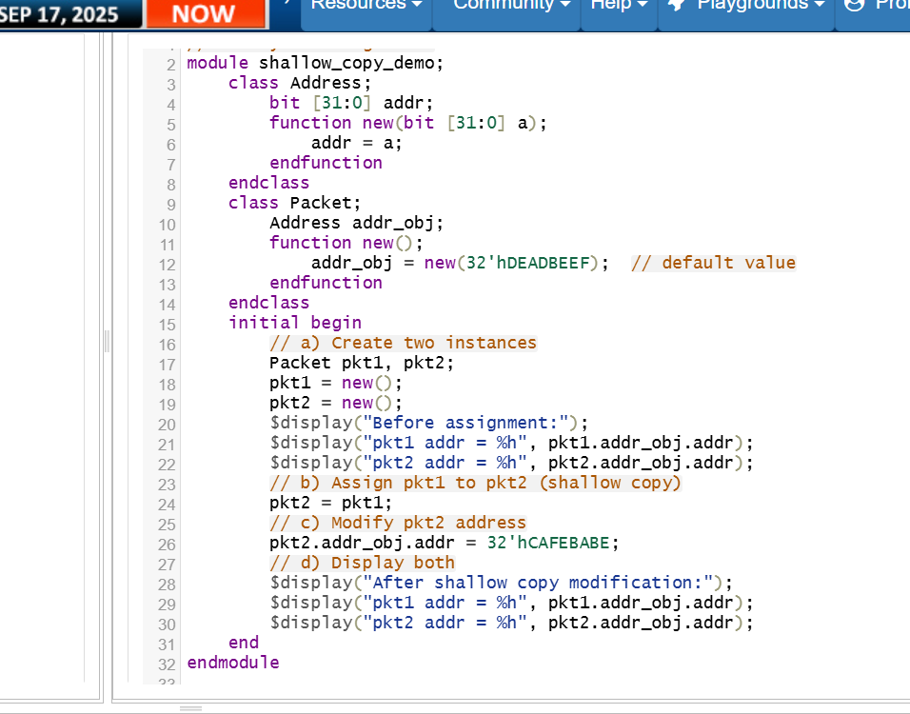

2) Semaphore

You are tasked with designing a simulation where multiple processes attempt to access a shared resource. The resource can only be accessed by one process at a time. Using a semaphore, implement the following:

a) Create a semaphore with a single key.

b) Define two tasks: access_resource and release_resource.

c) access_resource: This task should attempt to acquire the semaphore. If successful, it should simulate accessing the shared resource for a certain duration (e.g., 10 time units) and then release the semaphore.

release_resource: This task should release the semaphore after accessing the resource.

d) Simulate multiple processes attempting to access the resource concurrently and observe the synchronization behavior.
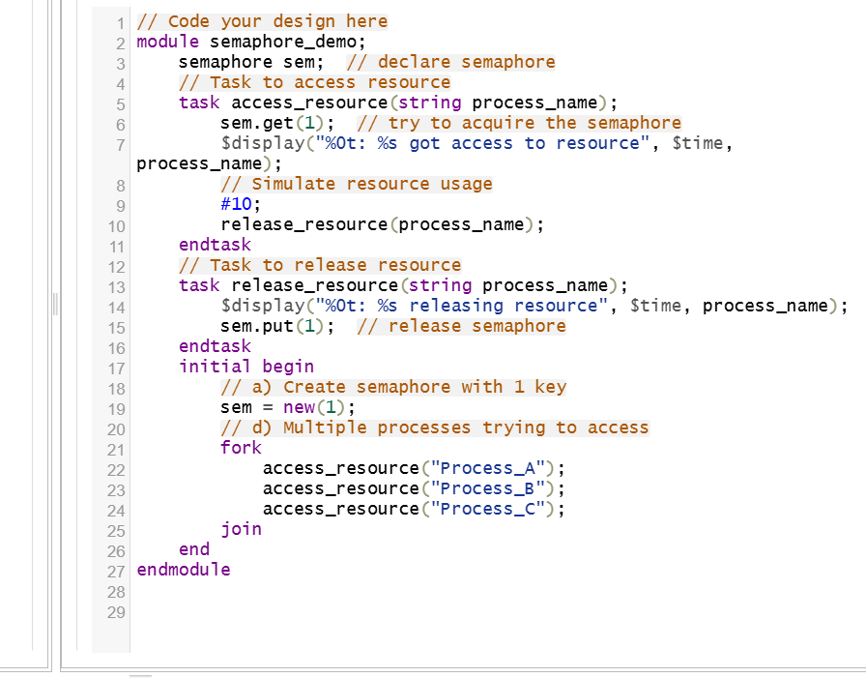

3) Mailbox

Design a producer-consumer system using a mailbox for interprocess communication. Implement the following:

a) Create a mailbox with a specified capacity (e.g., 5 items).

b) Define two tasks: producer and consumer.

producer: This task should generate data items (e.g., integers) and place them into the mailbox using the put method. If the mailbox is full, the producer should wait until space becomes available.

consumer: This task should retrieve data items from the mailbox using the get method and process them. If the mailbox is empty, the consumer should wait until data becomes available.

c) Simulate the producer and consumer tasks running concurrently and observe the data exchange.

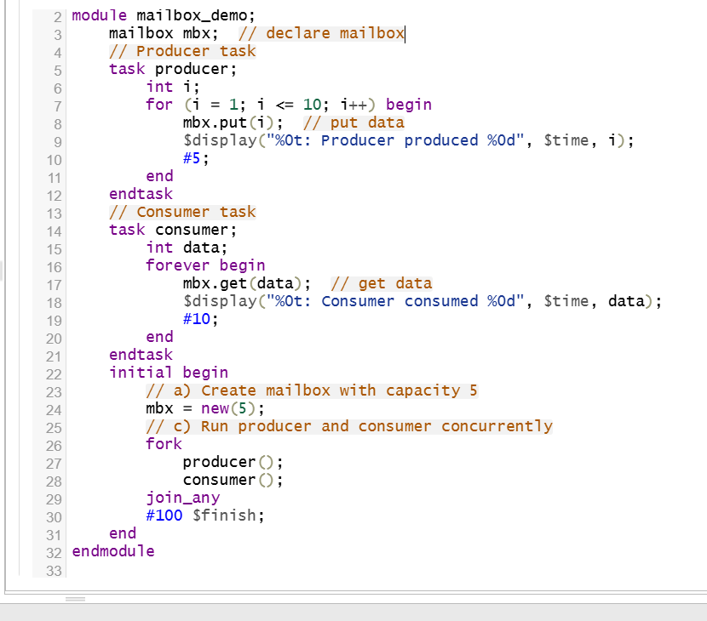

SAHMA.M
ECE
311123106055

